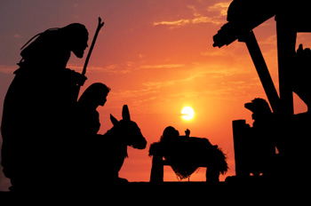
“The Word Became Flesh
and dwelt Among us . .
and we beheld His glory.”

Dear Friends, Family, and In-Pact Partners:

We greet you today, not from our home in southwestern Missouri, but instead from Medellin, Colombia, South America. Arriving Dec 7th, we are spending Christmas with our oldest daughter, Cindy, and her family, and will remain here until January 12th. Clearly this is not our usual Christmas, but is one, nonetheless that is most enjoyable we we combine holiday and ministry opp’s.

Special Praise and Prayer Letter Of

Bob and Jo Ann Tolliver
Life Unlimited Ministries
"Touching Nations Here and Abroad"

Number 099
December 23, 2011

Since we sent a regular letter earlier this month, we’re reserving this one to primarily send our deepest and most heartfelt Christmas greetings, along with a picture or two of Christmas in Medellin. Today the temp is in the ‘80’s, the daily showers that besieged us the first two weeks are generally over, and “the dry season” has begun. The wonderful breeze through the windows makes it quite comfortable as we write. The view from our bedroom window is amazing (See first two pix below). If you have Facebook, please take a look at several albums we’ve set up on Bob’s page (Go to lifeunlimited01 on Facebook if you’re not already on his friends list.)

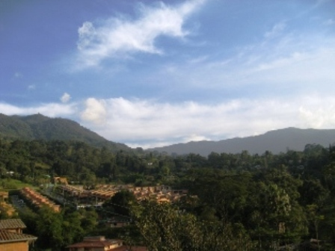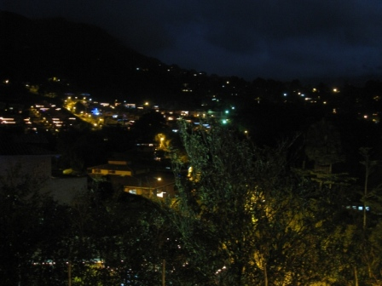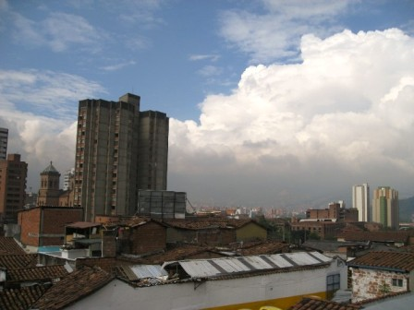

We’ve actually been pretty busy with ministry-related activities the first two weeks. We helped set up video equipment for a special children’s program the 9th, Bob preached two services on Dec 11th, we helped Cindy and Kevin host and serve an annual Bible school Board/Teacher appreciation luncheon the 15th, and we attended a special Christmas program by another church the 22nd where they again video taped the event. We were supposed to have attended a huge multi-church anniversary concert held in the bull fighting ring, but Jo Ann’s back was giving her major problems, so we weren’t able. Some 10,000 attended, and again, Kevin, Cindy, Christopher and their crew video taped the 5 and ½ hour event.

Medellin has been listed by National Geographic as one of the ten most beautifully decorated cities in the world for Christmas festivities. There are pictures on Bob’s Facebook page that certainly illustrate that fact. We hope to see the lights next week.

FYI, for those who financially support our ministry, if you want your contributions recorded for the year 2011, they need to be dated and postmarked no later than Dec 31st. We will send your annual contribution record the third week of January.

Since our space is gone in this special Word Document format, we will save the rest until later, encourage you to visit Bob’s Facebook page for several albums of our trip, and finally wish you a very special Merry Christmas and God’s richest blessing on you. We are eternally grateful for who you are and how you have blessed us.

In His Bond, By His Grace, and For His Kingdom,

Bob and Jo Ann

