
LUMglobal #109 June 4, 2013

Dear Friends, Family, and In-Pact Partners:
4
Hopefully, you will have no problems receiving this different version of our praise/prayer report. And, we pray this report finds you and yours rejoicing and sufficiently provided for by our faithful Father. Much has happened since our last report, so we’ll get right to it.

UPDATES:

+ Northeast KC: When we last wrote, we had a lack of clarity regarding our future in northeastern Kansas City. 1) The things we do best did not seem to find an ongoing slot to be a maximum benefit, 2) several changes had taken place with some of the people with whom we were working, 3) the financial load was not getting any easier, 4) and we were finding it more and more difficult to accommodate ourselves to the increasingly busy schedules of many of the folks with whom we were trying to work. So, after several months of prayer, we concluded . . . or perhaps better put . . . “hit the pause button” the end of April and returned to Collins.

To be sure, our diminishing ministry in KC was exacerbated by our own busy Spring schedule that we knew was taking us out of the area more than we really wanted. We don’t want anyone to think it was conditions there alone that led us to this decision. It really involved five factors, the last of which was our own Spring schedule that made the investment of further time and resources impractical . . . ESPECIALLY in light of something that was in the early developmental stage that we’ll share with you momentarily.

+ A Busy Spring: Before we interrupted our ministry in KC, God allowed us the opportunity to preach a few Sundays at a church that was dying and wanting to avoid closure by trying to do a “replant” under the leadership of John Mark Clifton and the Wornall Road Baptist Church. Armour Heights has a large impressive facility with a sanctuary seating 500+ and used to run over 600 in SS, but had dwindled to a handful of 15 to 20 people, most of who live outside the area. It’s our prayer that the “replant” will work and that it will again make an impact in that strategic neighborhood.

Not long after we moved our “transient belongings” from the house in Independence back to Collins, we hit the travel schedule . . . granddaughter Abby’s wedding April 27 in Jefferson City, speaking at Friendship Baptist Church in Mexico (MO) April 28, National Day of Prayer May 2nd, granddaughter JoyLinn’s performance of “The Little Mermaid” with the Academy of Performing Arts in Galesburg (IL) (to which we were unable to go at the last minute), preaching at Hopewell Baptist Church near Osceola (MO) May 5th and 12th, and then granddaughter Sarah Guinn’s graduation from Austin College in Sherman (TX) on May 19th.

Because we had been so involved in ministry, we had not taken any truly personal vacation time since the Spring of 2009, so we decided to reconnect with several relatives and friends in OK and TX at the same time . . . Hugh and Arlene in OK (whom we hadn’t seen in forty years),Terry and Rosie O’Toole in TX, cousin Lance Whyle and Mary in TX (whom we hadn’t seen in 13 years and only twice in 60 years), cousin Sara and Jack Rex in TX (whom we hadn’t seen in three), Doug Turner in TX (whom we hadn’t seen but twice in 50+ years), friends in Fort Worth, granddaughter Anya and family in TX, and friends Vince and Lesa McClung in OK (whom we hadn’t seen in 25 years). Even though we missed connecting with Ben and Sandy, Dan Marshall i, Jim and Jane Hylton, and Jay McFadden, it was a wonderful, memorable, and highly refreshing respite . . . all 2,000 miles of it. We returned May 28th to resume bringing our home out of “survival maintenance” mode from the past three years.

+ Farsi Ministry: Although we have not had any recent written reports from “M” in Kiev or “F” in Germany, we have talked with them on Skype several times, and have communicated via e-mail and Facebook. In a nutshell,

> The work in Kiev is taking a turn with some major changes in strategy as fewer Farsi-speaking students come to Kiev. The corruption among the police has grown drastically, and because of false arrests and bribery attempts many of the Farsi speakers have moved out of the city into towns and villages. Those who remain in Kiev are hesitant to be out for fear of police abuse, and those in the villages have difficulty traveling into town for corporate gatherings. As a result, “M”, “M2”, and “V” (mostly “M”) spend much time doing small group meetings, one-on-one discipling, and time-consuming traveling out to the villages.

> “M” also has redesigned the Farsi website and does much ministry in other countries via Skype. The guys maintain contact and encouragement with numerous believers when it isn’t too risky. The governments in the Farsi-speaking regions are increasingly more and more hostile toward non-Muslims. The guys also continue distributing Bibles and developing video clips for the Website, and maintain strong connections with the Farsi work in Germany, Sweden, and Thailand.

> The work in Germany, on the other hand, is exploding as more and more Farsi speaking refugees from Afghanistan, Iran, and Pakistan arrive weekly. We continue to marvel how God placed “F” in the one city in all of Germany to which these refugees are initially sent. For that reason, “F” now teaches 90 to 100 Farsi speakers the Bible every Sunday, and also meets with a group of about 20 core believers as he attempts to raise up more leaders. He also does small group and individual Bible study sessions . . . all the while trying to be a full-time post-graduate student.

> Finally, “M2”, “V”, and “F” have all lost their jobs and are facing serious financial shortfalls. The same has happened to “M’s” wife in Kiev and “H” in Sweden”. It is a difficult time for them all.
LOOKING AHEAD!!!!

Now, THIS is where all of these puzzle pieces fall into place ---- After 4 1/2 years, we are returning to Europe for an extended 3+ month ministry trip to encourage and help strengthen work that came out of our six years in Kiev, Ukraine. We now understand why our KC ministry was reducing and why we have had such a burden for our “Timothy’s” and “Esther’s” from the Kiev work. This burden was magnified as “M”, “F”, Tania, and others expressed their desire for us to come and help them. We have concluded that it was our own “Macedonian Call” from the Lord.

+ The Reason: Many needs have surfaced over the past several months to strengthen the works that KIBC began with the English, Farsi, and Spanish internationals. Significant changes have taken place since we left, and it seems time for us to go back to help strengthen those ministries and expand their effectiveness. It still amazes us what God did during those days and how, from one single location, that witness has reached to over 40 countries on five continents through those who were part of KIBC. We still marvel and are totally awed over what was clearly a “God Thing”. Maybe this is what the Apostle Paul went through on his second and third missionary journeys.

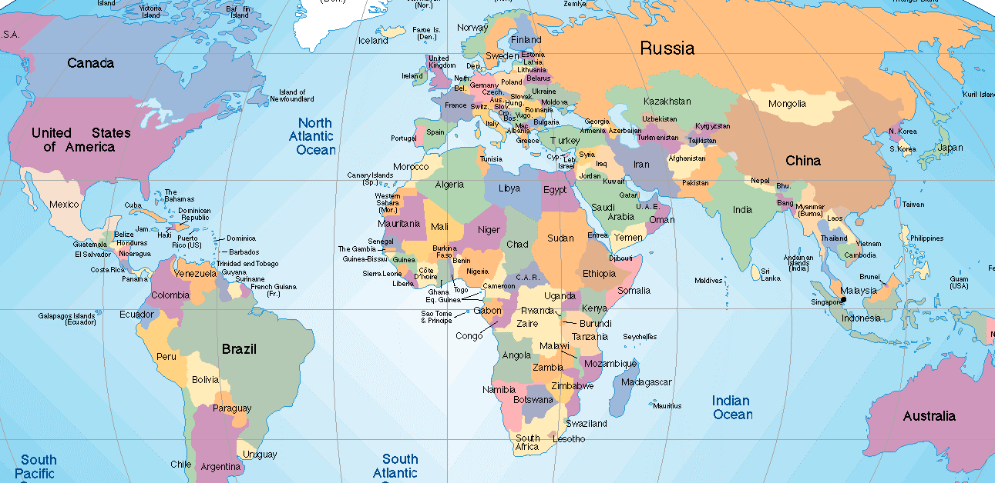

Out of the seven language ministries established, four became self-sustaining churches ---- English, Spanish, Chinese, and Farsi, and we will devote this trip to working with three of them ---- English, Farsi, and Spanish. Our primary target area will be the Farsi work, which as we already mentioned, has changed in many ways. The Farsi work is now in five cities in Ukraine, and over 2,000 Bibles in Farsi have been given, as well as major works in Germany and Sweden, not to mention numerous unnamed locations in the Middle East and SE Asia.

We will try to strengthen the Hispanic work and explore options for the English language work as well. From August into early November, we will minister in Germany, Sweden, Finland, and Ukraine, and will also make several short trips to other countries . . . possibly Croatia or others, depending on time and need.

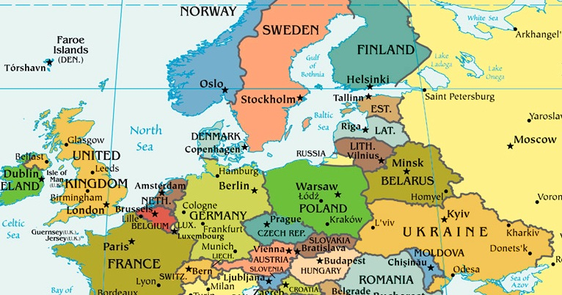

+ The Itinerary: Arriving around August 5th or 6th, we will headquarter in Giessen, Germany, for about six weeks ministering to many Farsi speaking refugees there and in surrounding towns. We will also speak in other churches including the International Baptist Church there. Giessen is the one city in Germany where the UNHCR initially sends all Farsi speaking refugees from Afghanistan, Iran, and Pakistan. “F” is the first Farsi-speaking person to accept Christ during 2005 in our work in Kiev. (“M” and “F” discipling new believers.)

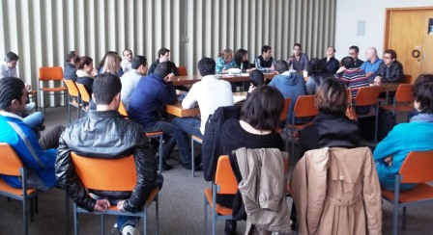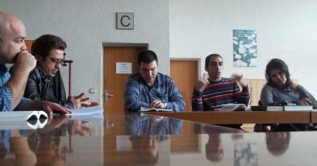

While in Giessen, we will travel to Sweden with “F”, to do evangelistic teaching, leadership training, and Bible doctrine for “H” and 40 to 50 refugees scattered throughout several towns and villages in the area. “H” was a refugee in Ukraine himself and was a part of the work in Kiev before the UNHCR immigrated him and his family to Sweden. We will spend two to three weeks there.

From Sweden we will travel to Finland, to be with our Cuban “daughter”, Tania, and her husband, Arto. We will hopefully spend time teaching and ministering to some of their friends who have lots of questions about a number of topics relating to family life, the Christian experience, biblical leadership, and discipleship before returning briefly to Giessen.

Near the beginning of October we will fly to Kiev, Ukraine, to minister for just over a month to the Farsi and Hispanic churches, as well as try to encourage those from the English work who are still in the area. We hope to work with at least some of the Farsi groups in other cities in Ukraine. We also hope to reconnect with a number of former colleagues who have continued to serve faithfully in the city.

+ Topics: We are being asked to teach and train in three specific areas . . . . Evangelistic Teaching:
> Evangelism -- People never come to Christ until they understand three things ---- 1) the fact that they were created for God, 2) their own need and inability to solve the sin and separation alienating them from Him, and 3) the truth about Jesus Christ and His claims about Who He is.
> Biblical Family ---- Many of the people we will be speaking to come from Muslim background where there is little healthy understanding of what a biblical family looks like. We will try to help them understand the amazing blessing of establishing and experiencing the kind of family life God has in mind.
> Multipling Disciplers, Building Leaders ---- The principle by which our work originally got off the ground in Kiev beginning in 2005 was the II Tim 2:2 principle. “The things that you have heard from me among many witnesses, the same you commit to faithful men who will in turn teach others also.” One of the greatest needs our leaders have is to motivate others to begin witnessing, leading people to Christ, and train those new believers to replicate what they have seen and learned . . . to help them do what we did with them . . . train others to train others. That is the only way a ministry of any kind can be ongoing in a fruitful and lasting way.

+ The Cost: Needless to say, this will be a costly ministry trip. Not only do we anticipate nearly $6,000 for trans-Atlantic and intercontinental air travel, but we must also carry overseas emergency medical and evacuation insurance ($3,000), apartment rent and utilities ($3,000), local transportation, food and living expenses, food and lodging for refugees coming in from villages, and funds for continued ministry support after we leave. If you would like a detailed breakdown of the budget, please let us know and we’ll send it to you.

Our overall need is $19,700. God has already been moving in people’s hearts even before we have done much to let people know, and over $8,600 has either already come in or has been promised. As of today, we still need to raise just over $11,500 of the budget. Of all that we have done in ministry the past fifty+ years, this trip is second in importance only to the six years we spent in Kiev. We feel it is vitally important to the salvation of many people without Christ, to the critical development of more leaders, and still greater expansion of those ministries. Because of up front costs before the trip itself, time has become of the essence as we get tickets this week, purchase supplies, make deposits on rental units, etc.

PRAYER REQUESTS:
> Our general health and weight loss. We have “general wellness” doctors’ appts this month, and need good reports for the trip. With his family history, there may be a connection with his struggle to drop the weight as rapidly as he wants. We also begin a series of treatments for chronic lower back pain.
> Funds for the upcoming trip. We still need about $11,500 in order to make the trip. If not all of it comes in, we’ll have to delete medical/evacuation insurance and special support we’re taking to each of the leaders, and possibly local transportation to bring the refugees in to the meetings and other events.
> Jobs for “Ira”, “F”, and “F”, all of whom recently lost jobs and are struggling.
> “V” and his family that conflict can be resolved and they can be reunited. He’s a key person in Farsi work.
> The work in NE Kansas City – Living Faith, Central, Eleos Coffee, the leaders, etc.
> The families throughout the Midwest who have suffered so much from the storms.

FINALLY:

Thanks for traveling this journey with us through your friendship, prayer, and encouragement. This is Life Unlimited Ministries’ 33rd year; it’s hard to believe it’s been that long. We marvel that God continues to use us and open doors of ministry for us in these later years when many our age have been retired from ministry for five or ten years or more.

There is absolutely no doubt in our minds that this ministry could have never done what we have seen if it had not been for the faithfulness and generosity of other believers like you who linked arms with us. We are deeply humbled and grateful beyond words. And, to add to our awe and our constant “Wow!”, we marvel at how God keeps opening doors at this stage of our lives.

As long as God gives us breath, strength, and the financial wherewithal, we intend to keep at it. All evidence points toward the fact that our freedoms are being lost, our nation is being forever changed, globalism is just around the corner, and opportunities are rapidly slipping away. Biblical predictions are happening daily.

So, . . . if God stirs your heart to partner with us in this trip, please let us know right away. We will send you information as to how to do that. It will bless you to invest in this part of Kingdom work, regardless of amount.

In His Bond, By His Grace, and For His Kingdom,

Bob and Jo Ann
The Tollivers
Life Unlimited Ministries

