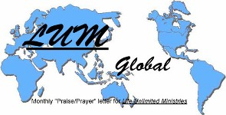

LUMglobal #110 July 31, 2013

Dear Friends, Family, and In-Pact Partners:

After first beginning to write this letter two weeks ago, things have happened that require us to start over and completely write over. By now you know about our upcoming trip, and you know about the recent health issues our dear friend and “son” “M” is facing. There is much to share . . . so here goes!

First and foremost, we must give our deepest thanks to those who really “stepped up to the plate” and responded so generously to the two major projects of this Summer . . . our upcoming three-month ministry trip to Europe, and the unexpected challenge to raise the funds for “M”’s cancer surgery. Between the two projects, we needed to raise some $33,000 to $35,000. And folks have responded amazingly. The cost of the trip has been fully covered, and we are also nearing covering the full amount of “M”’s surgery and follow-up treatment that will be necessary. So, a H-U-G-E HEART FELT “Thank you!!!”

WHAT WE’VE BEEN DOING:

Since our last letter, we’ve continued serving the Hopewell Church about 20 miles northeast of Collins. It’s a small rural church who recently lost its pastor, and, with the exception of two Sundays gone during our Texas/Oklahoma trip in June, Bob has been preaching there since the beginning of May after we concluded our year and a half ministry in northeastern Kansas City. They are a wonderful group of people who need to regroup and receive a fresh new vision for the future. Tomorrow (August 4) is our final Sunday as we prepare to leave the 8th for the three months in Europe.

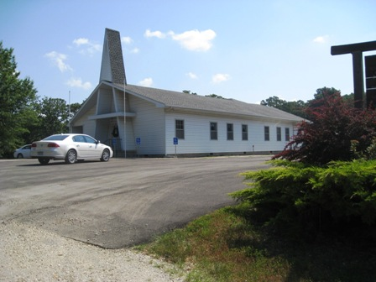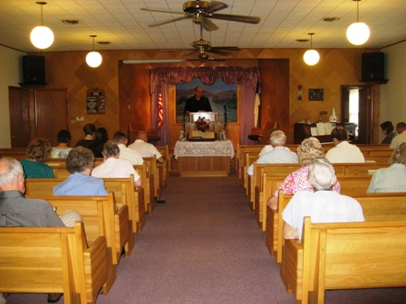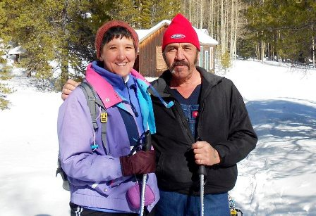

In addition to our ministry, granddaughter Sarah’s graduation from Austin College, and granddaughter Abby’s wedding to Nathan, our second daughter, Debbie, is getting married again soon to Mike Martinez. Sadly, our travel dates for Europe were set long before we knew about her wedding date, so we will not be able to attend. We’ve met Mike briefly via Skype, and look forward to a visit to Buena Vista, CO, hopefully next Spring or Summer. Deanna and family, and also Cheri will attend. Cindy’s, of course, cannot either from South America. Debbie moved to that area last year, and not only found great relief from her Multiple Sclerosis pain, but also a fine man with whom to share her life. We pray God’s abundant blessing on them.

UPDATE ON “M”:

As you recall, our “son” and director of the Farsi work we began in Ukraine in 2005, was recently diagnosed with a malignant tumor on his left kidney. This obviously shocked us all, but we still stand in awe of God’s hand in the situation. With no symptoms that there was a problem, his wife, Ira, insisted that he get a medical exam and, after her frequent prodding, he agreed. An ultrasound revealed a large mass on his left kidney. They returned to Kiev for more tests revealing the tumor covered over one half of his left kidney. Tests on his lungs and other organs showed they are clear. They were recommended to Lissod, a private Israeli clinic, staffed by some of the best oncological doctors in Europe, and no better place in Ukraine for the surgery.
The doctors there concluded that the 5.5cm tumor is malignant but had not yet metastasized. The head surgeon will do a combination orthroscopic and traditional surgery (because of the size of the tumor and the kidney) soon before it grows any larger. The tumor is within ½ cm of an artery. “M” has one final test to check the health of his right kidney, and assuming the radio active medication held up in a delayed cargo shipment at the border is released soon, is scheduled for next Wednesday, August 7th, and surgery will be performed the next day, August 8th. The clinic website is ---- http://www.lissod.com.ua/en/about-us/.

Because there is no medical insurance in Ukraine, several of us here and there are committed to raise the funds for the surgery. The total cost is between $12,500 and $15,000, and not the original $8,000 to $10,000 we mentioned before, because the surgery will include both orthroscopic and traditional procedures. We are amazed at how so many people have already responded, wanting to bless "M" and Ira by helping cover the cost. A significant portion has already come in over the past six days. We still need more, though.
So, we continue asking everyone to consider helping us raise the funds for the surgery and the follow-up recovery process over the coming months. We have an easy and quick way to get funds to "M", and have already begun that process. Thank you in advance if you decide to help us reach the $15,000 goal.
FARSI UPDATE AND NEW VISION:

The same day that “M” first learned of the tumor, he e-mailed the following report describing the new vision and the circumstances that have led up to it. You will be blessed and thrilled as you see how God has taken adverse circumstances in Kiev affecting the work there, and has used them to forge an amazing strategy.

These challenges remind us of a pattern we’ve seen in our own ministries. In the past 57 years we have faced seven major turning points in our lives, created by circumstances and factors beyond our control. Psalm 4:1 became real to us, “In my distress, He enlarged (expanded) me.” In each of those turning points, we found that rather than weakening or destroying our ministry or our future, it was either redirected, improved, or enlarged. We believe the same will be true for “M” and the Farsi ministry. Here’s “M”’s report:

New Vision and Directions

It is hard to grasp everything God has done since the beginning of the Farsi ministry in 2005. We never dreamed we would see it develop to groups meeting in several cities in Ukraine, plus the development of work in Germany, Sweden, and Thailand. We’ve also developed a secure website, we use Skype to answer questions, share the Gospel, and help train and mentor leaders, and we send Bibles to Farsi speakers in numerous countries. What started as a small bible study in Pastor Bob’s apartment, and translating worship service at KIBC, is now a network of multi-country ministries.

However, the situation has [changed], . . . over the past two years as immigration, political, and economic factors have taken place in Iran, Ukraine, and other countries. [Those changes] not only affect our current ministry, but also help shape a fresh and exciting vision for the future. It is important to understand the current conditions and the renewed vision so you can better pray for all of us responsible for the Farsi work.

As the number of Iranian citizens (especially students) [decreased] rapidly here in Ukraine, there are fewer Iranian citizens left than ever before. In 2005, when the Farsi ministry [began], there were more than 13,000 Iranians living in Ukraine. . . . because of the inflation and high prices (both in Iran and Ukraine), as well as the fact that the Iranian government is not accepting and accrediting Ukrainian diplomas, there are fewer than 700 Iranian students left in Ukraine now. When I first enrolled in the university I was attending, there were several hundred Farsi speaking students. Recently one of my former professors told me that this year there are only 18. Very few new Farsi speakers are coming to Ukraine for any reason because of various issues.

Regarding refugees, this situation is not any better. Many [have moved to] other smaller towns, as Kiev has become incredibly expensive. Over the past 2 months we have lost more than 8 refugees from our ministry. . . . to other cities. Many refugees [can’t get] proper documents, so they can’t travel in the city freely. The new Ukrainian government treats refugees very badly. Not only do refugees not get any financial support, but also their documents haven’t been extended for months (usually the UN needs to extend their documents once every 3 months). With an expired document, they are not able to get a job or travel in the city. If they get caught by the police, they could end up in jail for several days or weeks until someone bails them out.

The Farsi ministry however still continues holding Bible studies [every week] and Evangelistic events. . . . I’m just not sure if we’ll have many newcomers. Over the past 6-8 months as I’ve been watching the ministry . . . declining, I’ve been praying about the ministry’s direction for the future, because we know the work must continue. There is still a great need for Iranians to come to Christ and for strong faithful leaders to be trained. Finally, over the past month I’ve come to clearly understand what God wants me to do.

There are 4 new directions I believe the Lord wants us to pursue:

+ 1. Farsi Translation and Printing Ministry ---- The first direction is translating Christian books and biblical teachings into Farsi for Iranians in Iran and all over the world. There are very few solid Christian books in Farsi available. Because most Iranians do not know English, believers in Iran and other parts of the world are not able to get solid teaching. Christian satellite TV programs have been doing a good job evangelizing, but unfortunately the discipleship process has been forgotten. I have put together a team consisting of professional Farsi translators, editors, proof readers and computer specialists to carry on this ministry.

Over the past few months, we’ve translated 3 Christian books on Evangelism, the Church and the Christian life, and on God’s plan for Israel. In addition to all of this, several sermons and articles have been translated.
I have also been working through a secret channel in my home country to publish books which we have been involved in the translation of. Shortly 500 copies of one book will be printed and distributed to Christians inside my home country. Due to security reasons, unfortunately I’m not able to give any further details. However, if you are interested to know more, please drop me a note and I’ll be happy to explain more. A new project I am working on is the translation of, My Utmost For His Highest by Oswald Chambers. I want to have it translated by my team and have 500 copies printed in Iran. (Pastor Bob and Jo Ann also recommend The Master Plan of Evangelism by their longtime friend, Dr. Robert E. Coleman.)

Probably the biggest obstacle in a translation and printing ministry is lack of finances. Even though people on my team charge the minimum possible amounts, and the printer charges only for the paper and the necessary materials for printing, a book like “My Utmost For Hs Highest” would cost around $4,500 to be translated and printed. If you are interested in being a part of this ministry by helping financially or by helping us get the necessary permissions before translation and printing, please let me know. Thank you!

+ 2. Developing The Farsi website ---- The second direction is developing the Farsi ministry website. What has been translated is now found on the website where people can download and/or read it. My goal is to promote the website as a reliable resource for Farsi Christians where they are able to download and read solid Christian books and materials. Another goal is to get at least 20,000 monthly visitors within the next 9 months.

+ 3. International Mission Trips ---- The next new direction is making International mission trips to Germany, Sweden and possibly Thailand, to help Farsi ministry leaders with Evangelism, teaching and outreach. Over the past 18 months, I’ve made 2 such trips, and now I’m even more confident that this is what the Lord wants me to pursue in the future. There is even the possibility of me making a trip in August or September to Germany and Sweden to help Pastor Bob and Jo Ann in their teaching and training there.

+ 4. Writing a Book on How To Evangelize Muslims ---- For several years I’ve been thinking about writing a book about Islam, Muslims and Evangelism among Muslims. After the U.S. Boston marathon tragedy, I clearly felt the Lord’s direction and a “green light” to start writing it. It will take several months before I get it done. The title of the book is “How Mohammad Met Jesus”. The book will include my testimony, a defense of the Bible based on the Koran, a version of the history of Islam that every Christian must know to be more effective in Evangelism, and methods of Evangelism among Muslims based on my own experience. I’m also going to be talking about why terrorism happens, its root, and how it can be avoided in the future. Unfortunately I believe that the U.S. government, England and the European Union do not really understand the threat and mind set of Muslims. I believe they are moving in the wrong direction.

In conclusion, I would like to thank you for all your love, care and support. I praise the Lord for your partnership in the Farsi ministry.

In His Love, “M”

