OUR UPCOMING MINISTRY TRIP:

Little did we realize (you’ve heard us say it before!) what would come from the six years we spent in Ukraine serving as missionaries pastoring those two international English language churches. Our lives have not been the same, and the work continues to this day . . . not just in Kiev, but actually around the world, as the map showed in our last letter. Stan and Jean are in China, Deb is in Brazil, “F” is in Germany, Tania is in Finland, Senthil is in India, Maxim is in Thailand, “H” is in Sweden, “H” is in Iran, Mark is in Lebanon, . . . the list goes on and on. And now, we return to Kiev for only the second time since we came home, as part of a three-month trip to help strengthen some of the language works we saw birthed between 2003 and 2008.

We go to Giessen, Germany; Norsjo, Sweden; Tampere, Finland; and Kiev, Ukraine. Giessen is a university town of about 50,000 people just north of Frankfurt. All Farsi speaking refugees immigrating to Germany go to Giessen first. Norsjo is a tiny town of about 2,500 people near the Arctic Circle and is the center of numerous towns where Farsi speaking refugees are sent. Tampere is a city of about 300,000 and is the largest of all inland Nordic cities, two hours north of Helsinki by car. Kiev, established in 486 AD by Prince Kye and his two brothers and sister, is the capitol city of Ukraine with a current population in the metropolitan area of nearly 5 million people. All four cities and towns are characterized by the visible presence of internationals, many of whom are refugees.

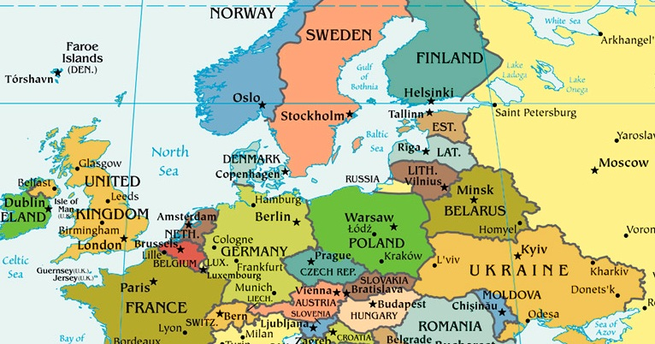

+ The Itinerary:

Our modified itinerary is as follows: So, here’s what things look like at the moment, give or take a few days;
+ August 9 – September 23rd: Giessen, Germany – teaching 90 to 100 Farsi refugees
+ September 24th – October 8th: Norsjo, Sweden – teaching 20 to 40 Farsi refugees
+ October 9th – 15th: Tampere, Finland – sharing with “daughter” Tania, Arto, and friends.
+ October 16th – 30th: Kiev, Ukraine – sharing with Spanish, Farsi, and English groups.
+ October 31st --: Return to Springfield, MO, and then home.

+ The People:
Tania, Carmen, and ‘Jesus (left to right) took the challenge to begin a ministry in 2003 to reach the 12,000 Latinos living in Kiev from many Latino countries. Starting with prayer walking around University campuses, visiting Latino cultural centers, and working with the Ukraine National Baseball team, a Bible study group of 25 people developed in ‘Jesus and Carmen’s one-room apartment. From there, as dozens came to Christ, the Upper Room Hispanic Church was founded in just a few months. Not only did they reach people from Hispanic countries, but MidEast and Asian countries.

After ‘Jesus and Carmen emigrated to Virginia, U.S., Cuban baseball player Raidel Arberay, married to Ukrainian-born Margarita, became pastor. In 2007 Tania immigrated to Sweden where she continued sharing the Gospel with Hispanics living in her town. ‘Jesus and Carmen now serve in Virginia where, as part of a local church staff, they lead a growing Hispanic group.
A year later Tania met a man from Finland, Arto, who eventually proposed marriage, and today Tania and Arto live in Tampere, Finland, where they serve the Lord in a local church and small fellowship Bible study groups.
In addition God opened the door for us to minister in Cuba where we connected with the church where Tania, Carmen, and ‘Jesus were trained as missionaries. We will visit and minister with Tania and Arto on the third leg of our trip, and will minister at the Hispanic Church in Kiev on the final leg.

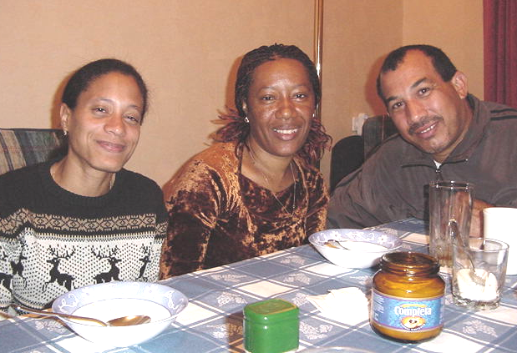

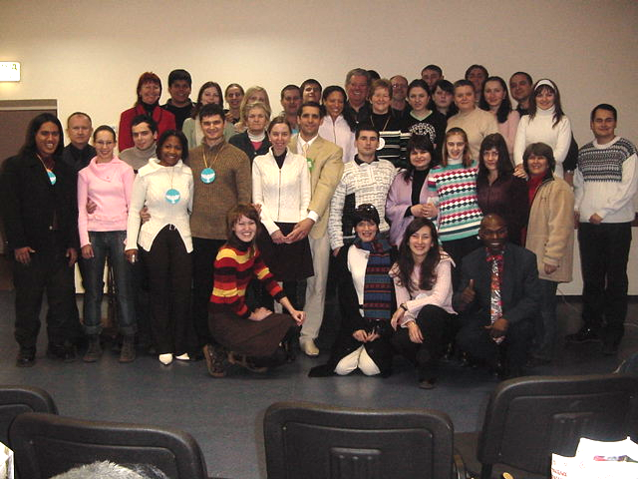

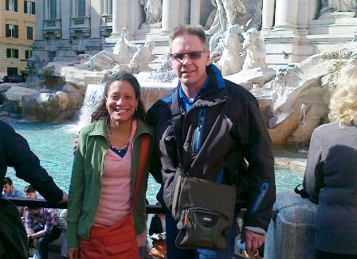

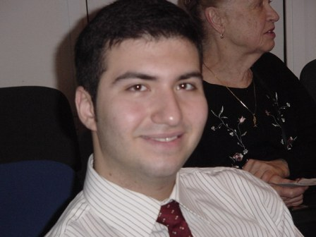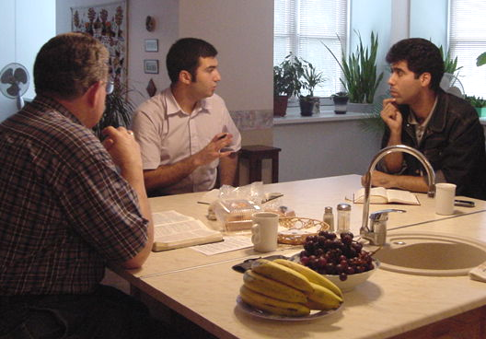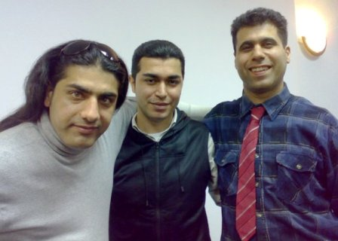

We met “M” in 2003 when he was a 16-year-old university student recently arriving from his home country. He attended services and English Bible study before going to India for a season. He returned to Kiev soon after we planted KIBC and committed to help us reach Farsi speakers with the Gospel.

Bob met weekly with “M” and “V” teaching them the Bible. What he taught one day they shared with their group the next day. The group quickly grew from a small Sunday afternoon Bible study to multiple weekly meetings and eventually a self-sustaining church. “M” leads the overall now multi-national Farsi ministry while “V” and another “M” provide general oversight the Kiev church work and assist “M” in general ministry and video production.
Of all the seven language ministries God enabled us to start in Kiev, the Farsi speaking work has been the most significant . . . for one simple reason ---- simple reproduction ---- the II Timothy 2:2 principle: “The things you have heard from me among many witnesses, the same commit to faithful men who will, in turn, teach others also.” It’s just that simple.

The first person “M” led to Christ in 2005 was “F”. When “M” approached him, “F” was already searching for answers . . . for Jesus. Soon after he became a follower of Christ, “F” said, “now what do I do?”, and “M” replied, “go tell someone what I just told you. “F” told his roommate, “M2” who asked, “now what do I do?” “F” said, “go tell someone what I just told you. “M” told “H”, and she asked the same question. That’s how it works.

“F” now leads an extensive ministry in Giessen, Germany where he teaches 80 to 100 Farsi speaking refugees and immigrants each week from Afghanistan, Iran, and Pakistan. We will spend the largest portion of our time working with “F” on the first leg of our trip, and then go together to Sweden on the second leg to work with another product of the Kiev work, “H” who emigrated to Sweden two years ago with his family. No pix from there yet.

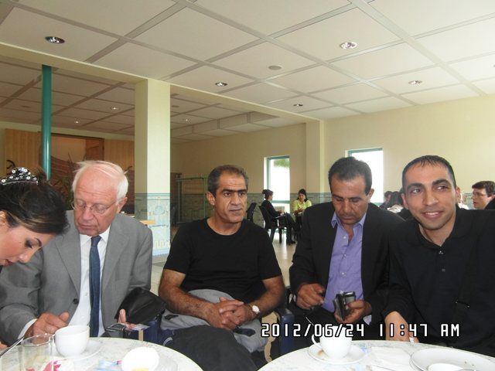
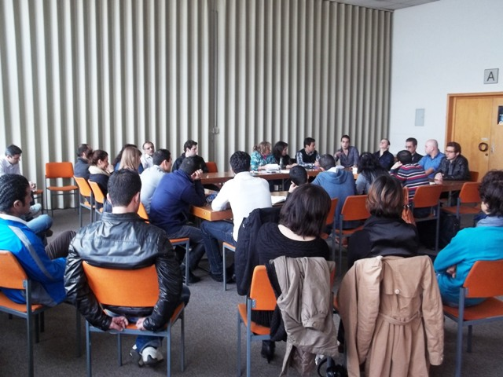
Finally, we will meet with folks from KIBC to fellowship together, and discuss the possibility or resuming some type of English language ministry. As you know, a large percentage of the core congregation moved because of job relocations or ministry changes. This was unavoidable. Yet, the spirit of KIBC lives on in several hearts, so we will talk and pray about what God may be saying about that. We look forward to meeting with one of our original leaders and dear friend, Vitaliy, and others both from KIBC and also Living Vine IBC where this all started.

FINALLY:

Well, that’s it . . . maybe more than you wanted to know. You surely know what our prayer requests are, so we leave it up to you to pray for “M”, his surgery, his family, finances, and all the folks involved in the four locations of this upcoming trip. Thursday is not far away.

In His Bond, By His Grace, and For His Kingdom,
Bob and Jo Ann (The Tollivers)
“Finally, . . pray for us that the Word of the Lord will spread rapidly and be glorified . . .” II Thes 3:1

