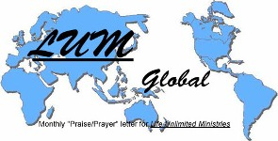

LUMglobal #111 August 21, 2013
NOTICE: We are thrilled to report that the tumor on “M”’s left kidney was benign with no sign of cancer. He continues rapid recovery from the surgery that removed his left kidney, the large tumor, and the adrenal gland. God provided not only the best surgeon & hospital in Ukraine, but also a vast prayer network & the financial resources to cover the cost of the surgery. The doctors said his improvement in the first two or three days takes most patients two or more weeks. Following some troubling reactions to the medication, he has bounced back quickly and is doing well. On his behalf, we thank all who prayed & gave. From beginning to end, God controlled all the affairs of the surgery. Continue praying for full healing. Below -- Wife Ira, “M”, and friend Ira.

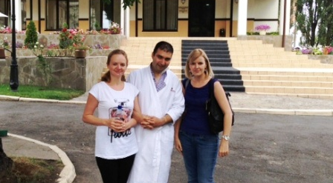
Dear Friends, Family, and In-Pact Partners:

Giessen: Greetings today from beautiful
Giessen, Germany, a city of 40,000 residents
& 25,000 university students. An hour north
of Frankfurt, it features the typical German
cleanliness, practicality, & ecology one might
expect. Almost totally destroyed during World
War II, it is now a modern city filled with cars,
bikes & an ethnic diversity with thousands of
immigrants & refugees who pass through seek-
ing refuge & new lives away from the hardships,
suffering & wars that plague their homelands.

Most come from Middle Eastern & North African
Islamic countries. Germany has generous
policies for foreigners, so many come for uni-
versity educations. After learning basic German
there are several schools nearby where they
can enroll, such as Giessen University with
25,000 students, or in nearby Marburg where
“F” attends along with some 35,000 other
students. Other schools are also nearby.

The strong presence of evangelical Christianity
in a predominantly secular / Lutheran country is
clear & opportunities for meaningful ministry
abound. The State of Hessen where Giessen is
located is the most religious and evangelical in
all of Germany. It would not be difficult at all to join hands with local believers to help share the Gospel & meet the needs of both the local residents & the immigrants & refugees who pass through the area.

Apartment: We are renting a conveniently located apartment from a Christian businessman with whom “F” works in one of the local churches. It is half way between the church building where we teach & minister on Sundays & the Christian coffee house where they teach German every evening & do a Gospel presentation on Thursdays. The renovation was not completed as had been indicated, so we spent the first four days with no hot water, just finished having the entire kitchen relocated to another room. It has “the basics”, so we buy other items as needed. It is adequate & comfortable. We think “quiet” has finally arrived. The only internet service available to us is in the owner’s office a level down and on the other side of the building.

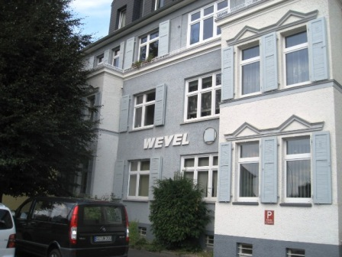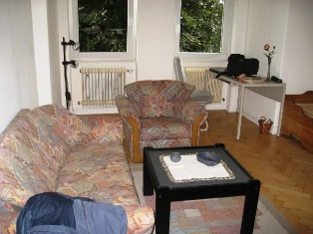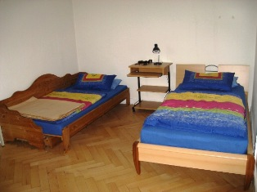

Sundays: Sundays and Thursdays will be heavy “work” days, with other days occupied with personal appointments and some small leadership training sessions on a couple of weekends. Sunday services are at 10:00, “bistro fellowship” around 11:30, our teaching time from 12:15 to 1:30, then a meal and fellowship until 3:00. Weather permitting, we will also host additional fellowship time in the garden behind our apartment so we can have more time with the Farsi speaking immigrants and refugees.

Thursdays: There are free German classes for immigrants & refugees from 5:00 to 6:30 at the “Kaffee Hope” coffee house, followed by an hour of conversational German over snacks. Then at 7:30 someone shares the Gospel and explains how to know Christ personally. Other days we will meet and minister to families and individuals who are struggling in certain areas. In September we will do a couple of week-end leadership development with a core group of young men whom “F” hopes will become a leadership team with him develop small groups in villages where they are scattered. Only one family actually lives in Giessen.
New Friends: We have already met some wonderful Farsi speakers and, as you can see below, many of them are younger families and individuals. After only two Sundays we already have many pictures to share with you, but space is limited. So, the best thing to do is to check Bob’s Facebook page periodically where we will post many more. In the meantime, here is a small sampling:

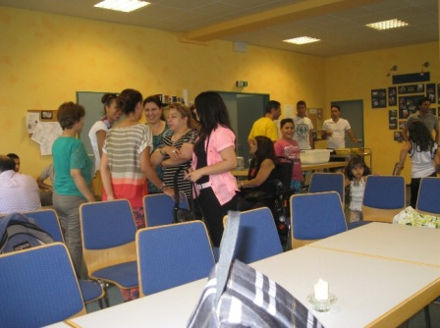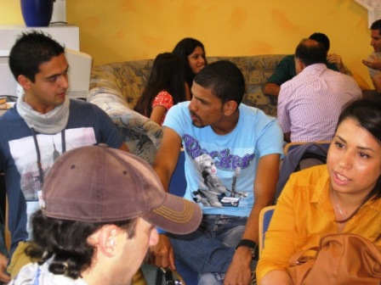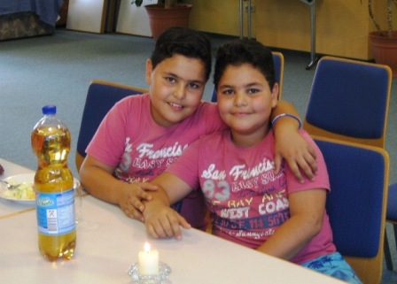

Needs: Few of the people speak English, but we already enjoy spending time with them. We have learned that not many of them are actually truly born again. Most have discovered that if they simply say that they are Christian and will be persecuted if they remain in their own country, the German government will grant them student visas or refugee asylum. Because Islam teaches that you become a Muslim by simply stating three times that Allah is God and Muhammad is his prophet, many assume the same is true for becoming a Christian. So, it is a long and laborious process to bring them to understand the truth.

Consequently, “F” is ministering faithfully to a truly mixed group of people. A few are truly believers, but only for a few months at most; one couple claims two years, but their marriage shows little evidence beyond Sundays that they really understand. Then you have those who have stated “Christian” simply to escape to Germany. Some claim to be Christians because they were baptized in the local church and a German believer told them they were now Christians. Others are openly secular, and still others are Muslims who come for the teaching, the friendships, and the meals. The pic on the left is Jo Ann speaking with a young mother, the center is a girl with an amazing story who has been here only a month, and the right is a pic of some potential leaders with whom we’ll spend a couple of full week-ends helping train them to become leaders. “F” is the shortest of the group in the striped shirt. All of them except “F” live in refugee camps.

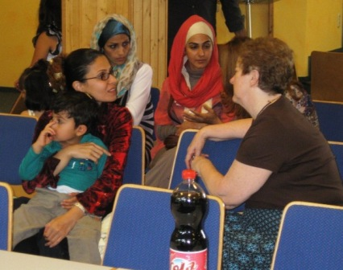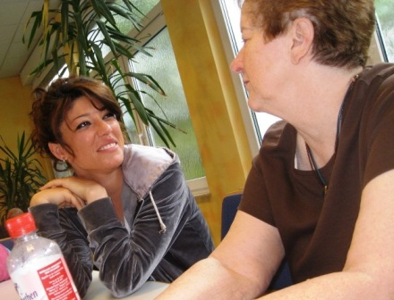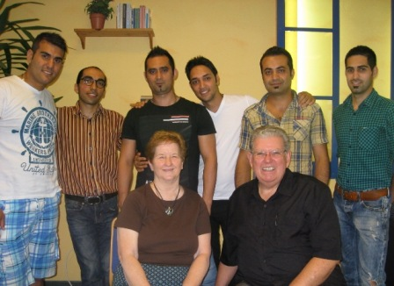

Leadership and Shepherding: It is difficult for “F” to reach these people and to discern those who can truly become strong leaders to help him. He not only has this mixture of spiritual conditions, but he also tries to deal with serious marital problems some of the couples are facing as they try to cope with the contradictory differences between Islamic and western/Christian images of marriage. As a fulltime student himself, he finds it impossible to be a “shepherd” to them, and he longs for someone to simply be a “pastor” to these families and singles who need so much help. It is a confusing, difficult, and laborious process. No wonder he wanted us to come and help him! “M” had told us beforehand what a challenge “F” faced, but we did not fully understand until we got here, listened to him describe the situation, and then actually met some of them.

“Kaffee Hope”: Thursday will be our second night at the “Kaffee Hope” gathering, and we are scheduled to share the Gospel there for the first time. Most of those attending will be refugees from many countries . . . Somalia, Benin, Iraq, Iran, Syria, North Korea, Afghanistan, etc. From what we’ve been told, it sometimes sounds like a madhouse when everyone starts translating at once, and we found that to be true last Thursday. It appears that we will speak in English, it will then be translated into German, and then all the other translators will jump into the fray speaking simultaneously to their respective language groups. Clearly we need your prayers. We will be speaking at around Noon or a little after (CDT) on Thursday.

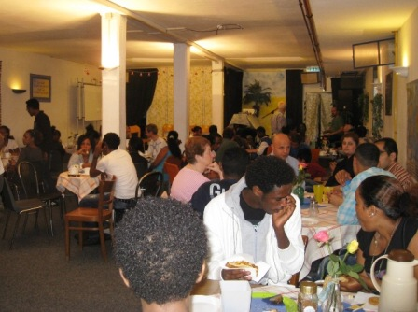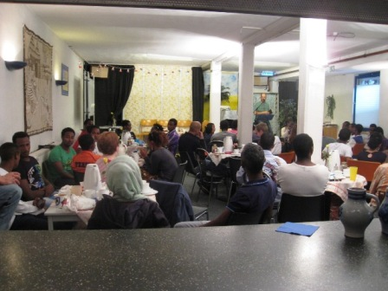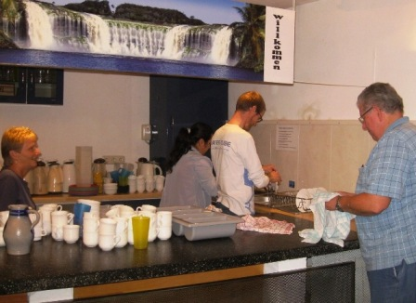

With file size probably maxed out, we’ll save more reports and pictures until next time. We’re anxious for you to meet some of our new friends, so go to Bob’s Facebook page and keep looking for our next letter.

In His Bond, By His Grace, and For His Kingdom, ---- Bob and Jo Ann, “Compelled To Go”

