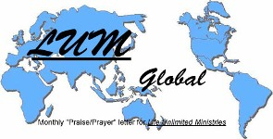

LUMglobal #112 October 10, 2013
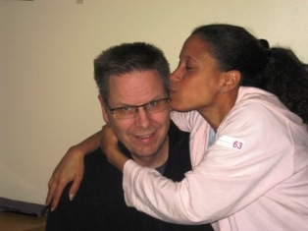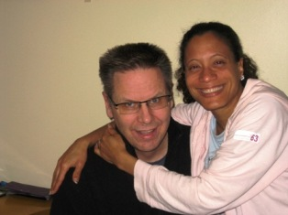
Dear Friends, Family, and In-Pact Partners:

Today we write from Tampere, Finland, where we’re spending a week
visiting our Cuban “daughter”, Tania, and her husband, Arto. Just
“coincidentally”, we are here three years to the week and day that we
helped “tie the knot” as they became husband and wife . . . October 7,
HAPPY ANNIVERSARY!
2010. It seems we have been gone from home such a long time, but
it also feels like August 8th was just yesterday when we began the
ministry journey. We’re already facing October 31st with mixed feel-
ings as we anticipate returning to the States but yet saying “good-bye” to so many very special people. In our August 21st letter, we had experienced just two weeks of ministry, and we have been trying to squeeze in time since then to send another update . . . all to no avail until today.

Giessen Ministry: The Giessen ministry among Farsi speakers continued to amaze us as we heard more stories, gained more friends, shared more biblical truths, and saw the enormous possibilities for sharing the Gospel. Space won’t allow us to share even a tenth of what we experienced. We grew closer to Ulrich and Krista Weyer (below left), the owners of the apartment and leader of his church’s ministry to immigrants and refugees. He is one year younger than Bob, and they have both been faithfully ministering to the outcasts, immigrants, and “untouchables” since the 1980’s. A businessman and past elder in their church, he continues urging the church into greater ministry and missions. Four days before our departure, we spent the evening together, along with “F”, talking about the possibility of our returning for perhaps even a longer stay to help “F” and them in ministering to the immigrants and refugees. We believe it is something about which we should seriously pray. In a final phone call the night before we left, he told us that we were like family to them.

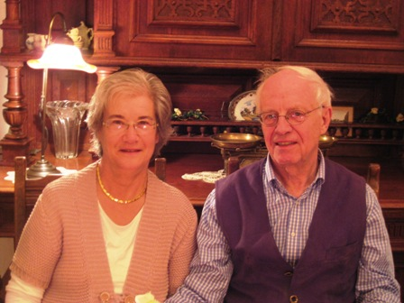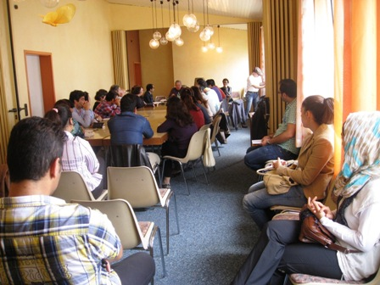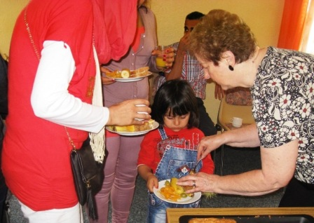

Attendance of the Sunday group grew in spite of more cramped quarters; 50 to 60 people came each week. By adding two extended teaching sessions, we were able to teach about “Created Exclusively For God”, “The Uniqueness of Jesus”, “What Christ Has Offered Us”, “God’s Idea of the Family”, “The Power of Forgiveness”, “The Uniqueness of the Bible”, and “How To Know Christ Personally”. Frankly, we have Never found such interest and hunger in the U.S. . . . even among unbelievers . . . as we saw in these dear people. We were shocked when “F” told us there are over 700,000 Iranians living in Germany, most as refugees. Stunned!

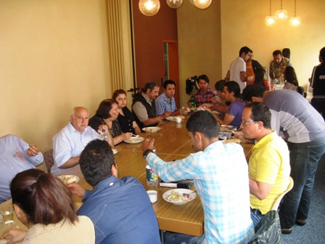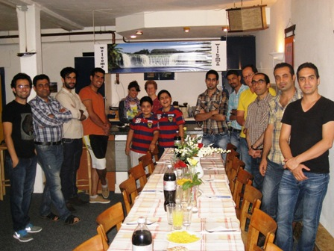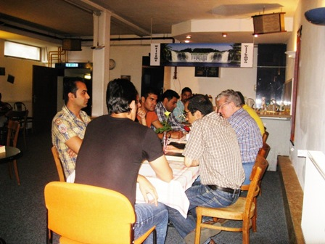

“F” arranged a week-end men’s retreat at “Café Hope” (above center and right) where Bob led three sessions to help create a leadership team to help “F”, who is a graduate student at a university 20 miles away, and not a missionary or a pastor (at least technically). One of the great needs he has is for some men to come and ease the load by taking on some serious responsibility. The guys set up the room arrangements and provided snacks while Jo Ann and “A” prepared a nice evening mean on Friday (above center in the back). Saturday we had back-to-back sessions and ended the retreat with a mid-afternoon lunch of pizza.

Bob ended up sharing the Gospel twice at “Café Hope”, both times to incredibly attentive crowds in spite of a noisy two-process translation (English to German and then to five or six other languages simultaneously). By his second time attendance in the German lessons had grown from around 125 to as many as 250, with many of them staying on Thursday nights to hear the Gospel teaching. As it continued to grow, they broke the groups into two nights . . . Monday nights for Eritreans (first night they had about 80) and Thursdays for all others.

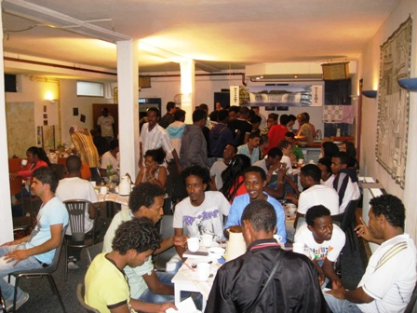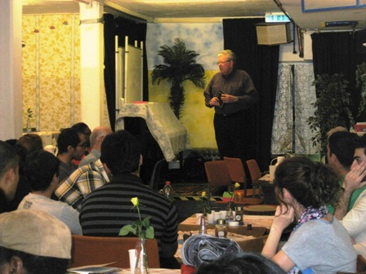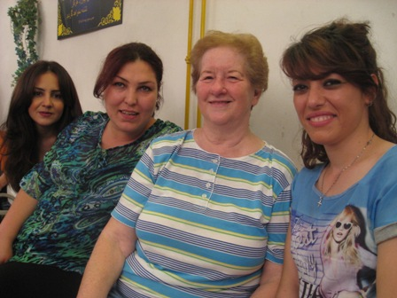

In the left picture you see many Somali’s, in the center you see “F” profiled on the left translating to the Farsi group for Bob, and in the right you see Jo Ann with three of her Farsi speaking friends. By the way, we asked regarding the welfare of those whose faces we show in our letters, and it is alright, and does not put anyone in danger, primarily because of the governmental policies and procedures that are in place in both Germany and Sweden. We also got permission from those who are shown “up close and personal”.

Sight Seeing Days: We actually had only three so far. One day Ulrich took us to southwestern Germany to float the Mosel River through castle and wine country (below left and center). The scenery was spectacular. Another day “F” took us to Marburg where he attends the university (below right). We enjoyed a walk in the rain with one of the Farsi families through the old city (it was spared destruction during WW II thanks to an American professor). Finally in Sweden we drove to Luleau in far northeast Sweden just 60 miles from the Arctic Circle where we visited with another of the young men from the Farsi work in Kiev. If you go to Bob’s Facebook page (lifeunlimited01) you can see many pictures. Three albums are already up with at least three more to come.

Sweden Ministry: There is so much to tell about the ministry in Sweden . . . so much, in fact, that we will save that report for our next letter. Our general assessment is, however, that it was much different than what we had experienced in Germany, but no less important. In Germany we ministered primarily to larger groups and secondarily to small groups, families, and individuals. In Sweden we had no groups larger than 25 or 30 people, and ministered extensively to small groups and individuals. In Germany we were located in one city. In Sweden we traveled to six communities and ministered in four. In Germany our agenda seemed to be planned out in advance. In Sweden, because of distance, transportation availability, and availability of the people involved, the work seemed to be more spontaneous with topic selection only hours or even minutes before ministry time. Yet, it was no less important and no less fruitful. God has His ways of reminding us He is in control. More next time.

Update on “M”: We are thrilled to report that “M” continues his recovery from his kidney/tumor removal surgery. His progress is excellent, and according to Skype calls, text messages, and e-mails, he is ready and waiting for our arrival in Kiev this coming Sunday afternoon. We will spend 20 days with him, other Farsi leaders, former leaders at KIBC, and other friends before returning to the States October 31st following an overnight stay in Frankfurt the 30th. We received the following report from “M” just three days ago, and include it in our letter to you even though some have already received it. We are super excited over his report, and think you will be as well.

><> ><> ><> ><> ><>

Dear friends,

It’s so good to be back to normal life again. In 5 days, it will be exactly 2 months that I had my kidney removal surgery. The blood tests I’ve been getting weekly show gradual improvements. I still need to keep on a strict diet. I’m feeling much better though. Few days ago, I underwent a scheduled screening. It showed swelling of a lymph node near the area of surgery. The doctor said that it’s not a very good thing, and I need to wait another month, and have another test done to make sure that it’s not something serious. It might be a simple irritation caused by surgery, or it also might be something far more serious. I choose to not think about it right now.Your prayers, love and support have been very encouraging, and have enabled me to focus on the Lord rather than on my problem. Now that I’m back to ministry, I’d like to bring you up to date on what’s been going on lately:

Farsi Translation and Publishing Ministry: With approximately 1.4 million Farsi Christians just in Iran itself, there are very few solid Christian books available in Farsi (Persian). Many new believers don’t have access to good teachings. Farsi ministry has continued translating materials into Farsi. Several articles have been translated recently. Currently, we are working on a book on persecution written by a missionary friend of mine. All the translated materials are available online on our website. We’d like to be able to continue publish the translated materials. We still want to translate and publish “My Utmost for His Highest” and are waiting for the Lord to provide the needed funds (approximately $4500). I deeply believe that the Lord is going to do something amazing through this book among Iranian believers in Iran. “F” (leader of Farsi ministry in Germany) and I have a vision to establish a Christian Farsi publication/translation organization and translate hundreds of books and publish them for Farsi speaking people. We don’t know when that would happen, but we are praying daily for that, and have already begun the process by taking small steps in translation and publishing. Unfortunately, there are only 2 Farsi Christian publications available worldwide, and both of them spend much of their resources on publishing controversial materials to prove to each other (and others) the superiority of Charismatic or Baptist understanding. That’s why hundreds of good books are still left to be translated and published.

Getting Ready for Pastor Bob and JoAnn’s Arrival: We’ve been planning a seminar for all who are interested to attend. Pastor Bob and JoAnn are going to be in Kiev from October 13 through October 30, and we are planning to have them teach and preach as much as possible. They are very dear to all of the Farsi speaking people in Ukraine. Not only have they helped plant Farsi ministry and nurtured it, but also they specifically trained me, “F” and “V” for years, so that we could lead the ministry and train others on our own. So you can imagine that we are very excited to see them.

Production of Video Programs: We’ve been making progress in producing video programs. We now have 5 people on the team. Few days ago, I shot five 3-minutes-long videos in the studio. We have also chosen 12 topics for producing a discipleship series. I’m going to start a Facebook page and a YouTube channel and link those to the website of Farsi ministry. In addition to all that, we have been discussing the possibility of satellite broadcast with managers of a Christian channel.

The goal of our programs is to disciple Iranians worldwide. Based on the statistics, there are around 10-15 million Farsi speaking people who watch Christian Satellite channels. Iran is also among the first 10 countries that have the highest number of Facebook users. We want to use all these [social media] channels to reach out to Farsi speaking people worldwide (approxi-mately 120 million).

The Lord has been bringing the pieces of the puzzle together for video production. One important piece that is still missing is a powerful Mac desktop computer. The reason a Mac is needed is that in Ukraine, almost all the video editors use Mac software that run on Mac computers to edit videos. We have someone in our team who is willing to help edit the videos for free. However, we need to have a Mac computer of our own, otherwise we need to rent a Mac and keep paying for the hours we use which in the long run, would be far more expensive that buying one. The friend in our team has a Mac at work, but is not able to use that for anything other than her work related tasks. Here is the specification of a kind we need: Quad-Code CPU, 2GHZ and higher, 12-16GB of RAM, Graphic Card with at least 2GB of memory. The cost of such computer is around $3000 for a brand new one. If you happen to know of a used one as well, please drop me a note. We are praying for the Lord to provide the funds so we could buy one for the ministry.

International Mission Trips: I’m inviting “F” (an invitation for receiving a visa) to come to Ukraine for Christmas and New Year. We want to do some sort of an outreach as well. Even though there are not many Iranians left in Ukraine, I still think we can plan Evangelistic events with “F”.

I’ve started learning German. Even though it’s going to be my 6th language I’ve ever tried to learn, the learning curve has been steeper than I thought. But I’m trying very hard and have seen some good results. My wife and I are planning to visit “F” in Germany in coming summer and help him with the ministry. Our initial vision is to travel to Germany for 1-2 months a year during the summer time. Since my wife knows German, English, Russian and Ukrainian, she can be a great help to talk to Eastern women who would otherwise avoid talking to me (or any other men around) due to cultural barriers. Summer time is the best time for ministering there. That’s when most of the refugees arrive due to good weather.

I don’t know how everything would work out in the future and how the Lord would lead us, but I won’t be surprised if one day the Lord would call me and my wife to move to Germany for indefinite period of time to help “F” with the ministry.

Writing the Book “How Mohammad Met Jesus”: I have already begun writing the book. Because of other ministry responsibilities, it doesn’t go as fast as I want. But I’ve been making some progress. I have sorted out the outlines and have moved to introduction. I’ve been also making more research on Islam lately.

Prayer Requests: Please pray for:
- My health as the Lord continues to heal. Please pray that lymph node swelling would turn out to be nothing serious. I’m grateful that the Lord has reminded me that I’m only living temporarily on the Earth, and should use my remaining life wisely.
- Farsi publication and translation ministry, for the Lord to provide necessary funds to translate more books, and especially “My Utmost for His Highest”.
- Video production and the need for a Mac computer.
- For my brother “Hamid”: As you know, he had a brain surgery around 3 months ago. Even though the tumor was 85% benign, the remaining 15% of malignant cells are highly dangerous and very aggressive. After undergoing radiotherapy and chemotherapy, recent CAT scan shows that the tumor has recurred, and he doesn’t have much time left to live (recent prognosis shows from 6 months to 3 years).He has a wife and 2 small boys as well. I’ve been praying for his salvation, and would like to ask you to join me to pray for him.

At the end, I’d like to thank you again for your friendship and true Christian “agape”. I’m also very thankful for your support, your emails and encouraging messages. I praise the Lord for our partnership in His Kingdom to reach out to the Muslims. Isn’t that great that one day all of us will have fellowship together at His presence for eternity, without worrying about our health, uncertain future, unsaved family members or any other problems? That’s truly amazing to me!

In His love,

“M”

Future Plans: As you can imagine, this trip continues to make a significant impression us and how we may feel God wants to use us in the future. Other than mission trips like this that take many months of planning, the rest of our ministry is planned only a few months ahead. Here’s what we know at this time:
- Oct 13 – Fly to Kiev for 20 days of ministry, flying to Frankfurt Oct 30 to spend the night & reconnect with “F” and other Farsi friends for some brief fellowship.
- Oct 31 – Fly to the States and home.
- Nov 04 – Consultation appt for Bob’s five-year colon check up, with procedure to follow soon thereafter.
- Nov 17 – 45th Anniversary Bible Conference at Calvary BC, Effingham, IL (17-20). Bob’s father was founding pastor 45 years ago. Theme – “What Does The Lord Require?”
- Nov 28 – Thanksgiving, plans unclear.
- Dec 25 – Christmas, plans unclear.
- Jan 27 – 55th wedding anniversary
- Jan 27 – State Evangelism Conference, Springfield, MO (27-28)
- Feb 15 – Barry County Bible/Evangelism Conference, Cassville, MO (15-17)
If things go as they normally do, most of our Sundays still unscheduled will fill in. We already know of three churches that want us to come and bring reports on this trip. So, we fully expect the schedule to fill quickly.

Needless to say, we are already hearing requests that we return next year around the same time to minister again to the Farsi speaking immigrants and refugees living in Germany, Sweden, and other places. We had been in Giessen only three weeks before we saw the need to find ways to help “F”, Ulrich, and others to share the love of Christ with Farsi speakers and others as well. The six weeks we spent there were the most exciting we’ve ever had since we returned to the States nearly five years ago.

There are adequate initial indicators already showing us we should at least be praying about a possible return:

- Many immigrants come to Germany in August and September.

- Universities are closed during that time so “F” and others can devote more time to ministry.

- “M” and Ira are wanting to come to Giessen that same time, and the five of us would be able to provide a beneficial ministry as a team once again.

- Housing is much easier to find during the months that university students are gone.

- If the Lord so led, we could also return to Sweden for times of ministry there. Both “H” who leads the Farsi work, and two pastors have asked us to return for extended ministry in numerous cities, to both Farsi speakers and Swedish people as well.

- Ulrich Weyel has already asked us to seriously consider coming back to help, and has suggested the possibility his church might have some resources that could help.

The Lord will make it clear to us if this is something for us to consider. There is no doubt that the need is great and the opportunities are vast. There has not been a time we can recall when the need to share the Gospel with people so ready to respectfully hear.

Prayer Requests: Seventeen years ago the Lord put Psalm 2:8 in our hearts . . . “Ask of Me, and I will surely give the nations as Your inheritance, And the very ends of the earth as Your possession.” This remains the driving motivation of our hearts and our ministry. So, please pray with us about the following:

- For our health and strength to continue on as God opens doors. The episode Bob had during the early part of the trip appears to have corrected itself. Pray for a good report on upcoming medical exams.

- For “F” and all the people in Giessen involved in sharing the Gospel with immigrants and refugees.

- For “H” and his family, Marcos, and Pastor Karlsson and his wife and congregation as they serve faithfully . . . both separately and cooperatively . . . in sharing the Gospel with Farsi speakers throughout northeastern Sweden.

- For our upcoming meeting at Calvary Baptist Church in Effingham, IL, that God will give clear direction as to the messages we need to share.

- For “M” and his family as they continue serving in Kiev and giving general direction to the growing ministry to Farsi speakers. Pray for the full recovery of his health. Pray that the funds needed to translate books and purchase the equipment needed for video production will be provided quickly.

- For our ongoing need for strengthening the financial base of our ministry. We could do so much more if the resources were there.

Finally: Once again we thank God for you, for your prayers, encouragement, and support. We are humbled to have been given the mandate He has placed on us, honored that we’ve had that exceptional privilege, and grateful that He has blessed us with so many people who believe in us and trust us with the investment of their lives into our own. We’d love to hear from you . . . lifeunlimited@pobox.com, grandma12@pobox.com.

In His Bond, By His Grace, and For His Kingdom,

Bob and Jo Ann
The Tollivers

Life Unlimited Ministries
LUMglobal

