

**STILL**

**LUMglobal #117 July 2, 2014**

Just a brief note to update you regarding our planned ministry trip to Germany and Myanmar. Because of low financial response so far, the Myanmar part of the trip (pics just below) has been cancelled, and the Germany portion has been significantly shortened and is at risk of also being cancelled as well.

We are so grateful for those who have giv-en, often generously and sacrificially. And, we cannot thank them enough for what they have done. We know of others who have helped in the past simply cannot do so at this time. We don't take them for granted.

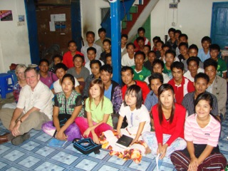 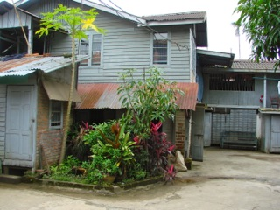

Of the $20,170 needed for the entire trip, only $7,630 has been either given or promised to date. Already several weeks behind schedule in securing tickets, we wanted to keep you abreast of the situation. Our original departure date was to have been the first week in August, but will probably have to be delayed some.

In addition to cancelling the Myanmar portion of the trip, we have trimmed the Germany portion down to six to eight weeks instead of ten, depending on funding available. It is not preferred to go for less than eight weeks, and virtually impossible to do much in less than six. The revised budget looks like this:

**Six week trip ----- $10,215**

**Eight week trip ---- $12,820**

We will make our final plans depending on any future funds that may possibly come in. With the $7,630 promised or on hand, that means we need just under $3,000 for the six week trip, and just over $5,000 for the eight week trip. If sufficient funds do not come in, we will cancel the rest of the trip and return funds. All checks sent are being held un-deposited until we see the outcome by the end of next week.

In review, the Germany trip will feature "M" and his wife joining us from Kiev for a number of days to help with ministry being planned by "F" for Farsi speaking refugees and immigrants from Afghanistan, Iran, Ukraine, and parts of Tajikistan and Pakistan who fled their homelands for political, religious, or economic reasons, seeking asylum for a new life, safety, and greater freedom. We spent two months with "F" last year ministering to such people, and there is a great need to do the same with many new immigrants who have come since then. In addition, we will help strengthen those who are still in the Giessen area.

We will share the Gospel with a large group each Sunday, provide teaching and counseling to struggling families, help train new leaders, and travel to other towns to meet with small groups and families. In addition, we hope to again minister at the "Café' Hope" where we can share the Gospel and host evangelistic discussion groups not only with Farsi speakers, but also with refugees from numerous other countries.

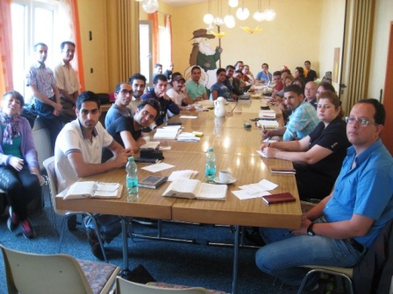 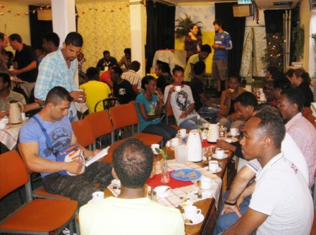

If you want to share in this project, please let us know right away. Everything needs to be on hand by the end of July so we can access funds via ATM's in Germany.

Rejoicing In His Bond, By His Grace, and For His Gospel,

**Make any checks out to Life Unlimited Ministries, with "Farsi Ministry" on the Memo Line.**

**Send them to . . .**

**Life Unlimited Ministries, Box 228, Collins, MO 64738.**

Bob and Jo Ann

The Tollivers

417-693-5149 (Bob)

417-693-5313 (Jo Ann)

lifeunlimited@pobox.com (Bob)

grandma12@pobox.com (Jo Ann)