   
                       **Issue #118**

**July 9, 2014**  
Dear Friends, Family, and In-Pact Partners:

It has been a few weeks since we sent out a full-blown LUMglobal to everyone. We have important news on a number of things, and we want to pass this information on before our next major ministry project. Here's our report on the major topics:  
  
**+ All Funding In:** What great news we have to report! As of last Sunday, enough funds have been either received or promised that we can make our two-month segment of the trip to Germany. Because of the generosity of a church where Bob had served as interim pastor in the past, the remaining $3,000 was authorized just a week ago. Thank you so very much, FBC, Eldorado Springs, MO!!! Your faith in us is humbling; thank you.

**+ Germany Agenda:** What began as a three-month trip to Germany and Myanmar, was reduced to the cur-rent two-month trip to Germany as a follow-up to last year's trip to help "F" in ministering to Farsi speaking refugees and immigrants mainly from Afghanistan, Pakistan, Iran, and Tajikistan. As last year, we will teach and serve not only with "F" as part of Kiev's "Father's House" ministry, but also with Café Hope, the ministry of evangelism to immigrants begun years ago by Christian businessman Ulrich Weyel and wife Krista. We will be teaching on the general theme "Created For God", and it will include the trustworthiness of the Bible, God's plan of restoring us to Himself, and God's blueprint for the family. We will also teach in other communities, as well as being in homes. "F" told us Bob will be driving a church car at times. (Yeek!)

**+ Christopher Graduates:** We have another grandkid who has graduated from high school. Christopher Elder, Cindy's and Kevin's son, graduated with honors and as a member of the National Honor Society from the Columbus International School in Medellin, Colombia. This major accomplishment is even more note-worthy when you realize that he received both U.S. and Colombian diplomas.

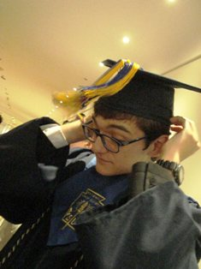 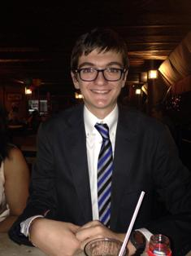 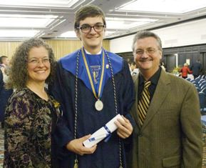

**+ Youth Camp Missionaries:** Who could have ever imagined that, at our ages, we'd have been invited to serve as camp missionaries for a bunch of teenagers! But, that's what happened. Just this past Thursday we returned from Pulaski Baptist Association's annual camp where we had the amazing privilege of "sharing our stories" of missionary work with some 100 teens. They were an incredible group, and many asked questions in each session and a significant number of the young people came to us personally afterward for further discussion and expression of appreciation for our being there.

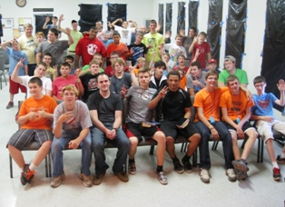 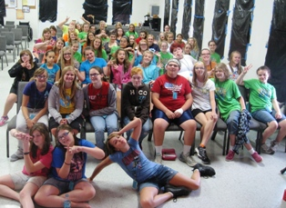

**The Guys!**  **The Ladies!**

**+ Update on "M":** Those of you who receive only our "snail mail" version of our letters perhaps do not know that "M" in Kiev received his military call-up notice for military duty. However, because of his kidney removal surgery last year, he is not physically capable or qualified to do military service. Fortunately, he was put in contact with "a person who knew a person" who ultimately put him in touch with a military doctor who quickly recognized "M's" condition that disqualified him from military service. As of last mid-week the doctor has initiated paper work to place him on the "ineligible" category where he belonged from the beginning. The pro-cess should take about two weeks before everything is finalized. Please pray that this process is successful. We would like to further strengthen his ministry support financially. If you would like to be part of that either as a one-time or a monthly commitment, just let us know.

**+ Situation in Ukraine:** Needless to say, we all continue our concern for what is happening in Ukraine. We have numerous friends, both American and Ukrainian, still in the immediate areas of conflict. Not only has "M" and his family been affected, but all Ukrainians have. "M" tells us that the Ukrainian government, doesn't even have funds, because Yanukovich and his ilk financially and morally ravaged the country, to provide the soldiers with boots and bullet proof vests. Inflation has sky rocketed, and the end to the war in eastern Ukraine seems to be far from over . . . especially as Putin continues providing military advisors and heavy duty military equipment to the Separatists and terrorists.

At the same time, there is a major spiritual move in Ukraine. From the beginning of the demonstrations against Yanukovich last November, prayer movements, cross-denominational church meetings, humanitarian aid, and expressions of compassion and service have consistently increased, and they continue today. So, while the fighting continues, the ground swell of spiritual unity and intercession increases as well.

**+ Ministry Elsewhere:** Our Syrian friend, Saied, is still in southern Russia and seriously in need of financial support which we are unable to provide. His wife and two of his sons remain in Syria under very dangerous conditions. Still, with his brother and eldest son, he continues trying to minister to Arabic speakers living in several cities in the area. Our Ukrainian friend, Sergey, and his family and tiny congregation continue shar-ing the Gospel with the Buryat people in Siberia. God provided the funding for a vehicle, so the small teams of evangelists go out from his church to the many villages, sometimes a great distance, to share the Gospel. People are being saved on a regular basis.

**+ Our Health Situation:** We are very happy to report that both of us passed our annual "wellness" exams with flying colors. Jo Ann's blood pressure was even better than in past exams, and Bob's was still irritatingly low at 118 over 62 with a pulse rate of 60. His LDL was the only concern with just two points above normal. Both of us passed the new "cognitive" questions with perfect scores. Jo Ann's doctor told her that she was the first one in her age category who had answered all questions correctly.

**+ Family News:** Cindy, Kevin, and Christopher are home from the mission field in Colombia for a year to do itineration (support raising and report giving) for their next term, and are living in a missionary colleague's house in Polk City, IA. Christopher is enrolling in college at DMAC in Ankeny near home as he transitions into college life. Debbie and Mike remain active in church and community activities in Buena Vista, CO, and enjoy hiking in the mountains and foothills. Cheri and Bob remain in St. Paul where they get to spend time with grandkids – Sergei and Stacey's little guy took a tumble recently ending up with a concussion. Roma has successfully adopted Anya Marie. Jim and Deanna are currently facing a big challenge as she has been recently diagnosed with breast cancer. The malignant "aggressive" tumors were caught early and have been removed, but they now must make the decision as to the type and level of treatment she will receive.

**+ COMMUNICATING:** It's unclear how good the internet connection will be for us while we are gone these two months, so we expect to minimize our use of Facebook and e-mails to only necessary pertinent corres-pondence. However, we'll try to post pictures as we are able. We know we'll have internet, but don't know how reliable. Feel free to write to us or message us on Facebook. Bob hopes to send his weekly "Shoulder To Shoulder", and we expect to send at least one issue of LUMglobal, and perhaps two, while gone.

**+ Prayer Requests:** Needless to say, we have many prayer requests. Here are some very important ones.

* **For Jim and Deanna as they seek God's direction regarding treatment for her cancer.**
* For safety & good health as we travel Thursday to Giessen, Germany.
* For increased strength, endurance, & spiritual insights as we minister two months in Germany.
* For "F" as he provides on-site leadership & oversight to the Farsi groups in & around Giessen.
* For the Farsi speakers & others who will hear our teachings, that they truly give themselves to Christ.
* For current & future leaders whom we will be instructing & training while in Germany.
* For protection of our house & belongings while we are gone these two months.
* For Melody & Danny as they check our mail, pay our bills, water our shrubs, & look out for our home.
* For For Cindy, Kevin, & Christopher, as they travel, speak, & raise support for their next term.
* For "M" & his family as he seeks exemption from military duty in Ukraine, & for their financial needs.
* For the Farsi ministry in general as "M" & others make decisions & plans for future expansion.
* For opportunities of ministry in churches upon our return the end of September.

**+ FINALLY:** Words are truly inadequate to express our appreciation for the love, intercession, and financial support for Life Unlimited Ministries, and especially this current assignment God has given us.

**To those who support Life Unlimited Ministries, mail will be checked and deposits made weekly while we are gone, so you can safely continue sending your gifts and contributions as always. If you want to help "M", Saied, Sergey, or others, please designate it on the Memo line.**

In His Bond, By His Grace, and For His Kingdom,

Bob and Jo Ann Tolliver

Life Unlimited Ministries  
Box 228, Collins, MO, 64738